SCREENSHOT FOR LAB 9

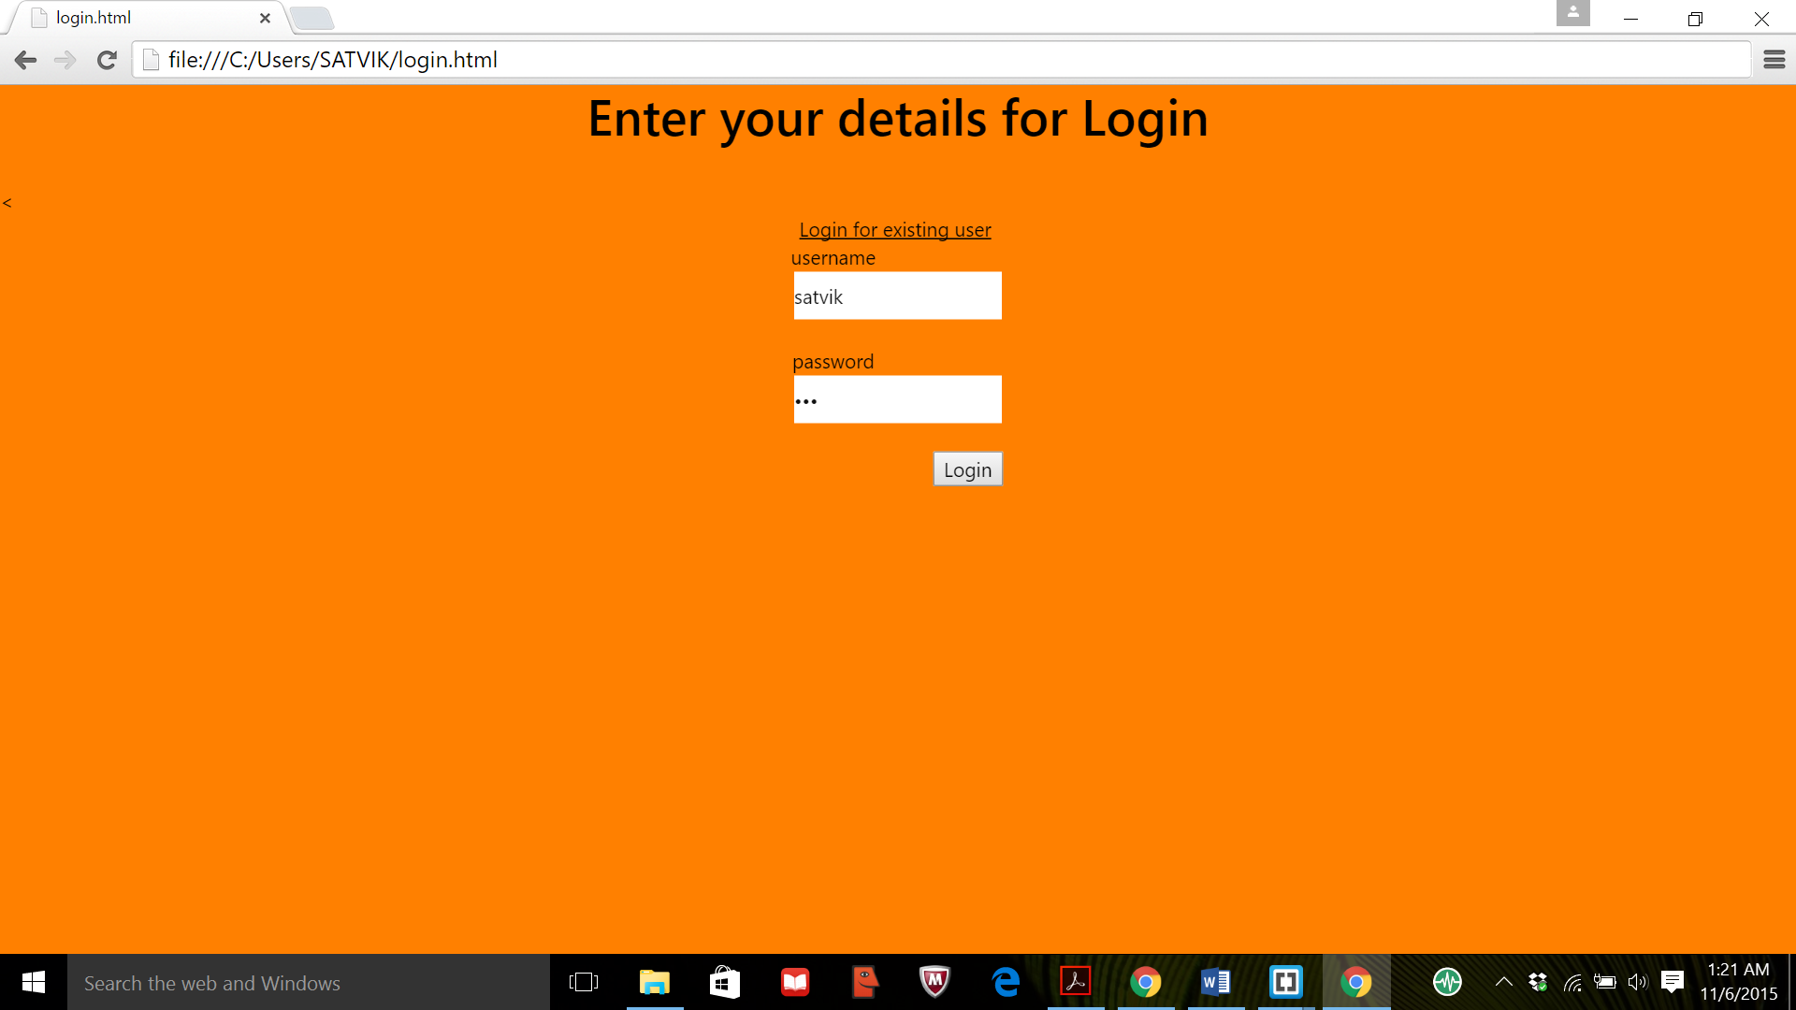

In above we implement singleton pattern here only one user are allow to use the system

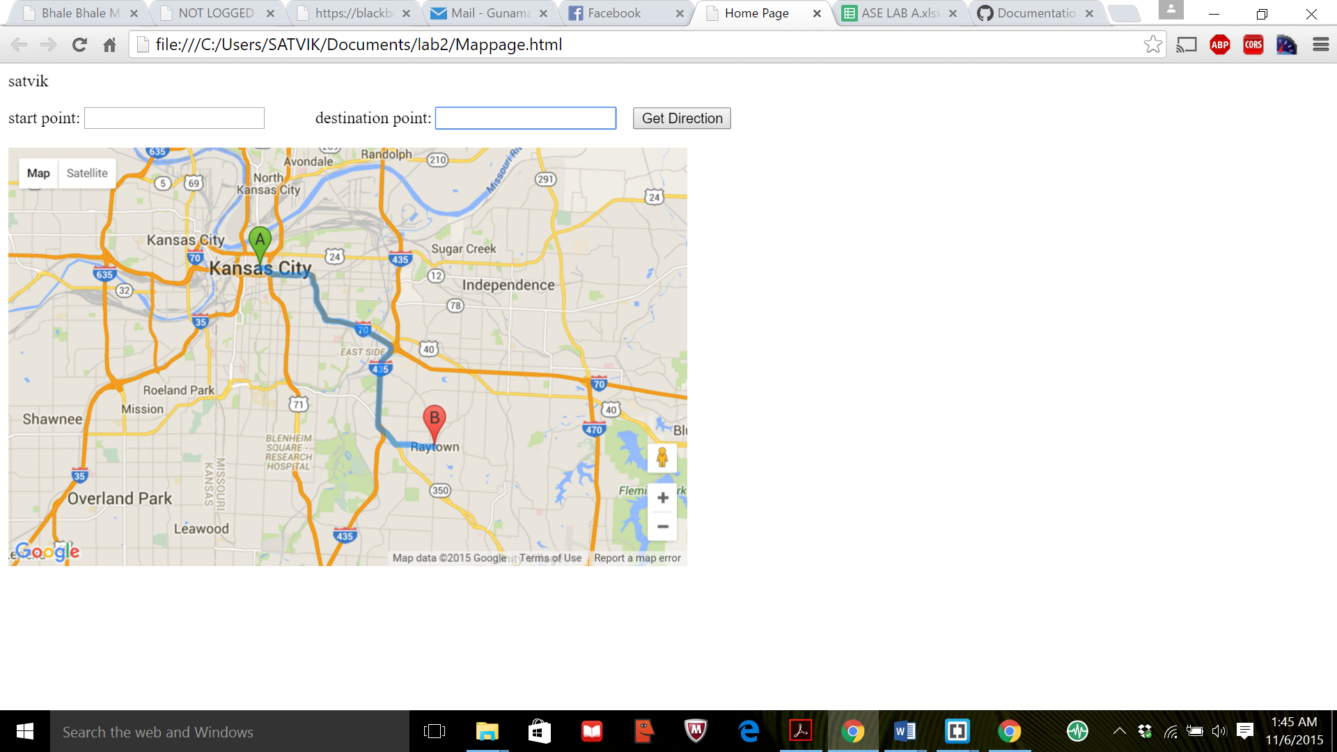

For factory design pattern as user log in into system user name display into home page of application

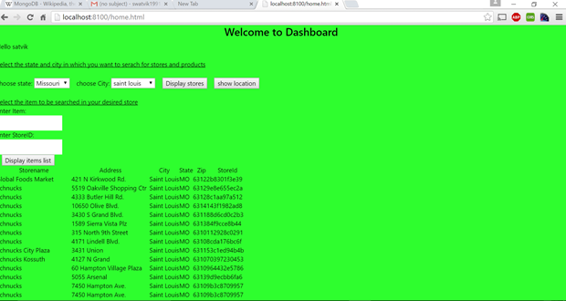

For mixin pattern design pattern user get details of product in particular area